# Names:

**Optitrack computer**: computer with optitrack system connected to it

**chain computer**: computer where labview code controls the chain system

# Setting up optitrack:

1. Open optitrack:



`



When opening optitrack, go to the stream tab and set the local interface to loopback

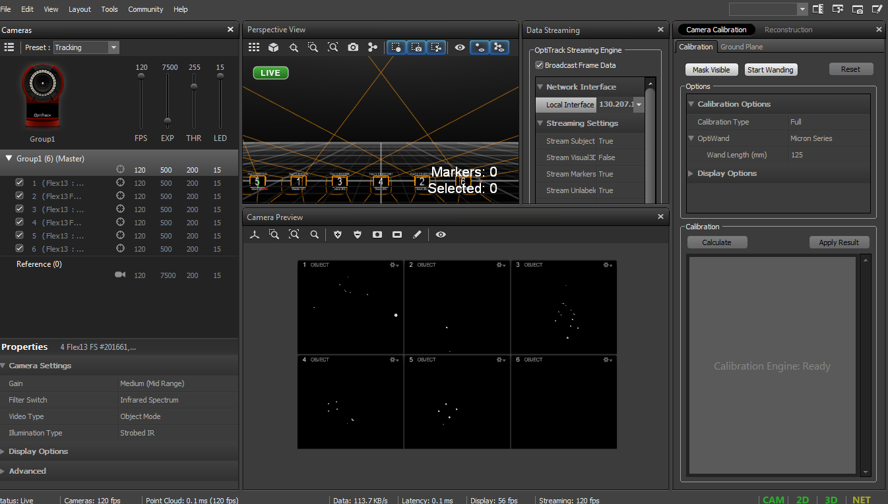

130.207.141.229 is the IP address of the computer and this is also the IP address that the chain computer connects when sending a trigger to matlab which sends a signal to start recording on optitrack to start recording an experimental run.

# Setting up cameras/choosing locations

Place cameras in location where they are all pointing at the system try to use different heights

An example of a good setup is shown above with the camera fps and exp and threshold values shown.

When you’ve eliminated lights except for the tracking markers you can start to calibrate the system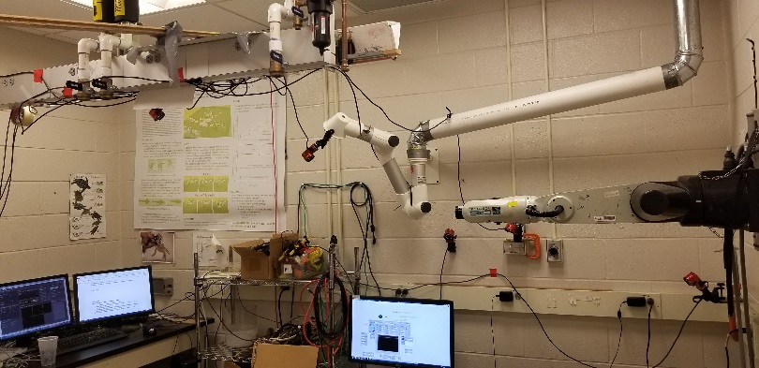

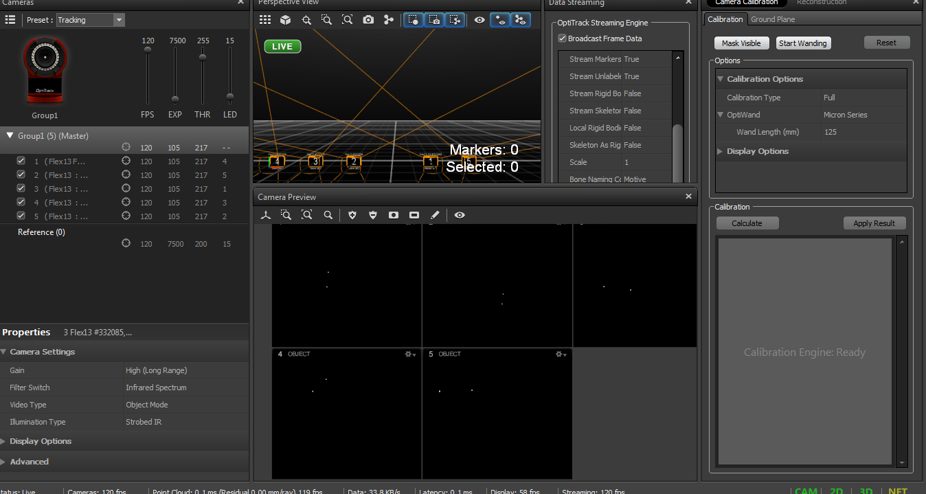

# Calibrating

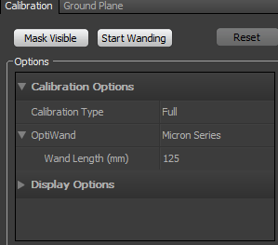In the calibration layout (layout->calibrate), make sure calibration info is setup as shown below

You will be using the 3D printed calibration wand head with the wooden shaft.

1. If there are any markers in view first click “mask visible”
2. A popup will show asking you to set a project root folder click yes and then yes on the file explorer in the folder it opens.
3. Any visible markers in the pictures will now be red, indicating they are hidden from the cameras shown in the image below

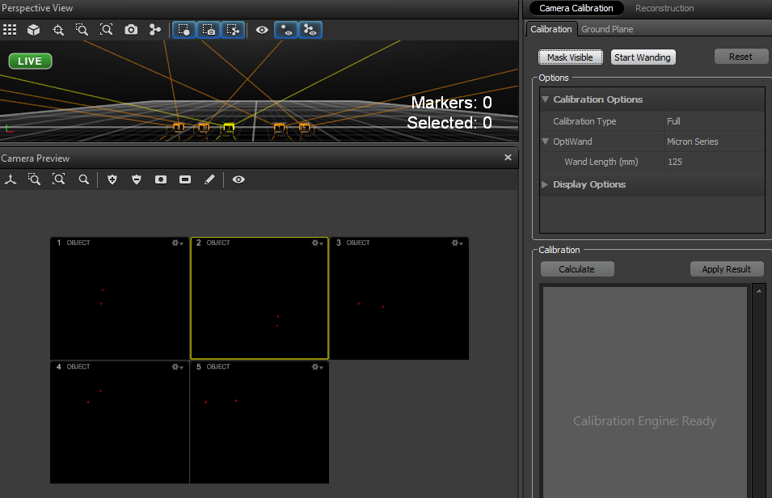

If you need to remove the mask, (which you will after you calibrate) for any reason, click remove mask button shown in red box below

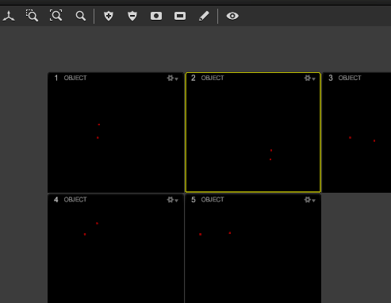

A

1. After all markers are invisible to the cameras, (either not there or masked) click on start wanding
2. Take the wand and wave it around the area, move slowly and at a more or less constant speed. Try to get at least 2k samples on each camera, keep going until the box says “very high” as shown below
3. 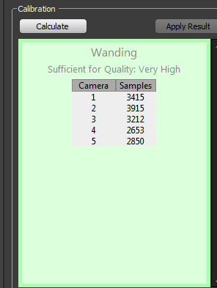Now click calculate, it should take a few seconds and then a window will popup. Try and get all cameras to have completely full bars and the mean 3d error to be <.1 mm if you can. If not just recalibrate. If all boxes show up red and the mean error shows up with something like #Q.0, close optitrack and reopen (don’t forget to change local loopback setting in the stream interface tab)

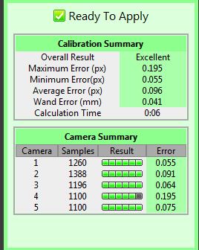

1. 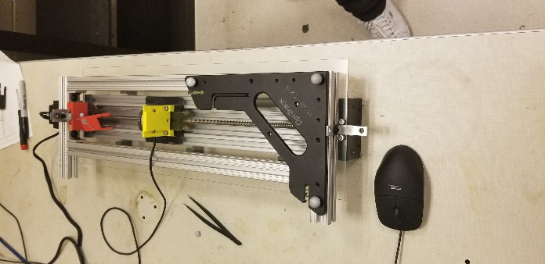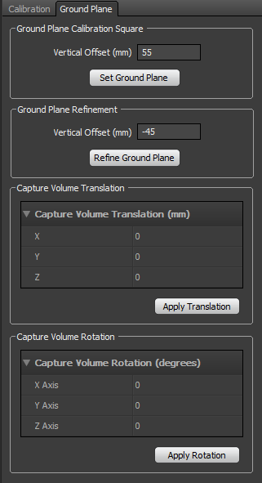Optitrack will switch to the ground plane page where the calibration page was, as shown below. Place the calibration square lined up with the chain system like it is shown below. Make sure the screws (on the underside of the calibration square) are laying inside the central grooves of the 80x20. Once it is in place click the set ground plane button. Say yes to any popups that appear
2. The system is now calibrated so you can remove the calibration square and set it aside.
3. Make sure to remove the image mask
4. Now in the top menu go to Layout->capture to go the screen which you will use to take data in.

# Taking data

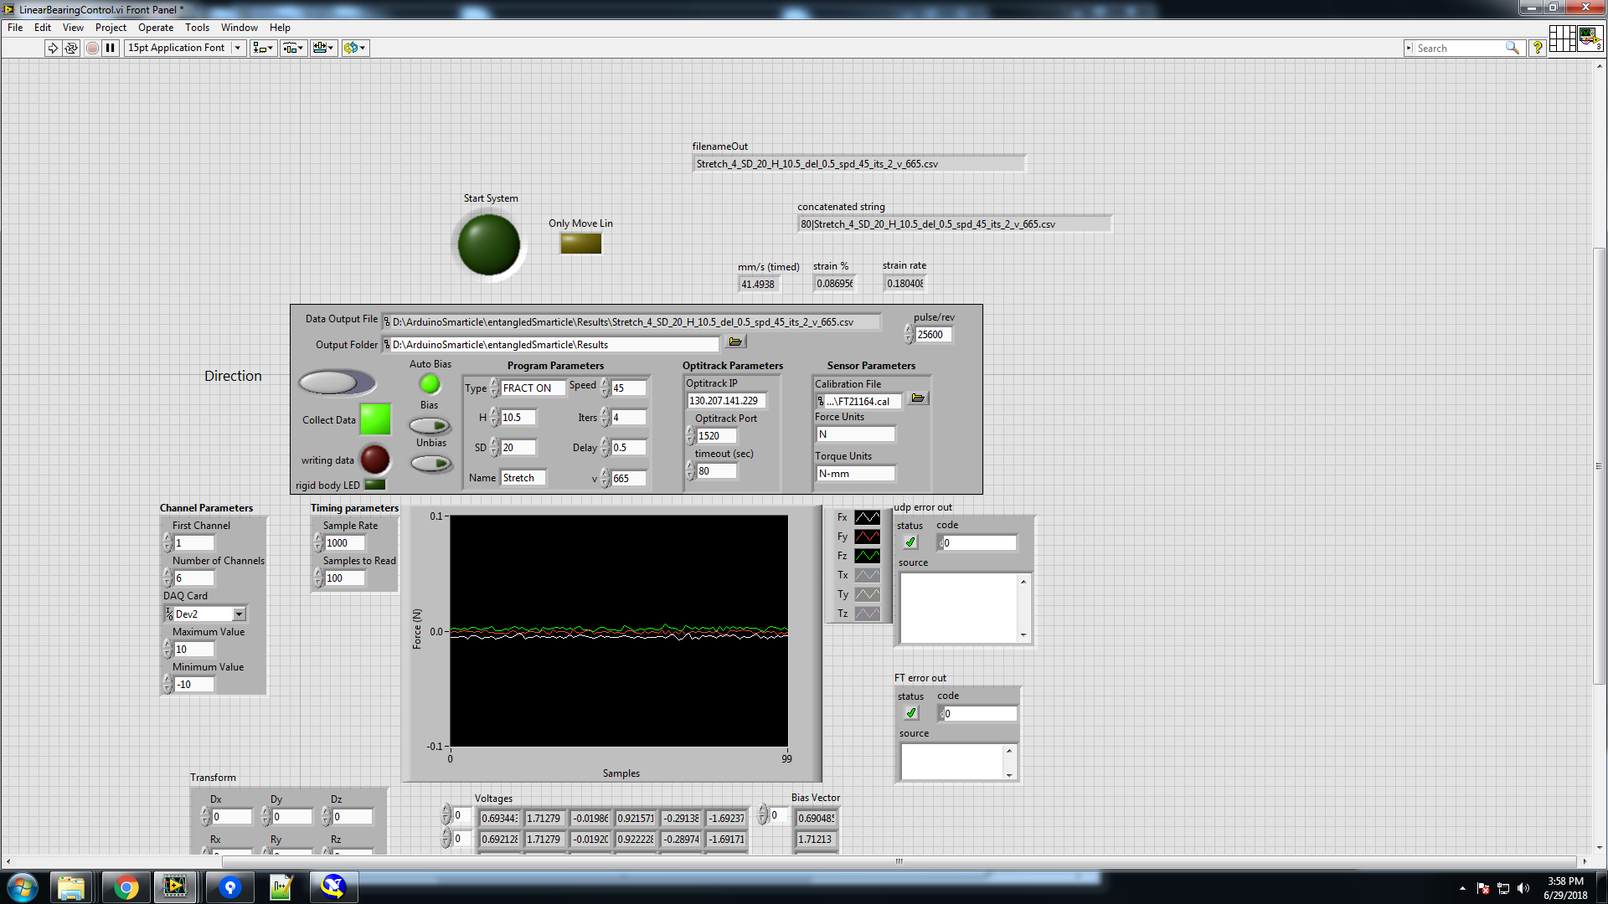

Type of experiments you are doing

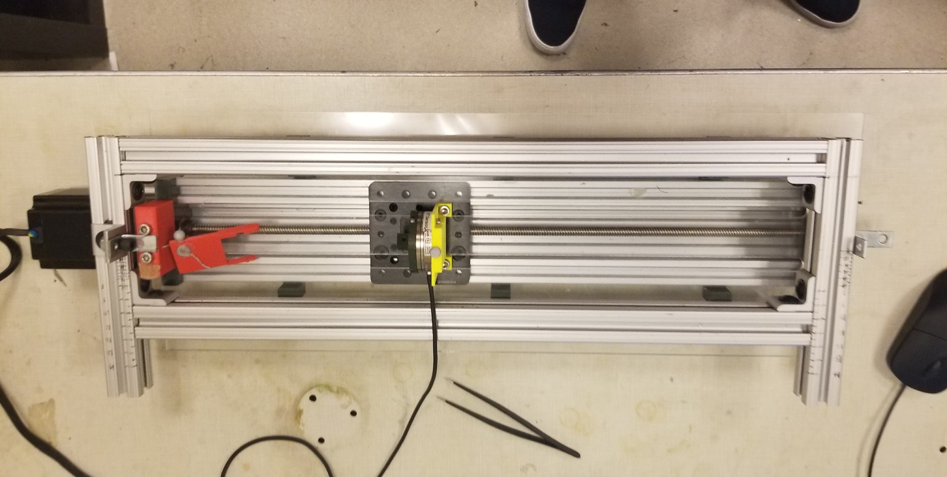

H

# Debugging

**Optitrack isn’t being triggered from the labview program**

1. Check that both computers are connected to the internet
2. Check if optitrack has set the local interface in the stream tab to the ip 130.207.141.229 (which should be the ip of the computer)
3. Run the UDPserver script in matlab “A:/ArduinoSmarticle/entangledSmarticle/linear bearing setup/matlabScripts/UDPserver.m” is running in matlab
4. Both computers need to be on the same network (with same DNS (school of physics))